1st line title
2nd line title
Name Surname ¹, Name Surname ², and Name Surname ¹
¹ Institution, City, Country
² Institution, City, Country

Abstract
This word document is formatted and this section is written in formatting style ‘standard’ (or ‘normal’, depending on the languages settings of MS Word). All formatting styles are defined in the style gallery. Please keep the compatibility mode activated so that the format does not depend on the version of MS Word you are using. When inserting text from other documents please use “paste special insertion of text only” – the only exception to this is the copying of figures and tables within this document. This is easiest done as simple copy-paste in order to keep the numbering and cross-references intact.
Keywords: 3 to 5 keywords, 1st line
2nd line (if necessary)

Heading 1

Heading 2
Heading 3
In this template, references are formatted as textmarkers, Johansen [1] and Eurocode 5 [2].
Table 1 formatting style: caption table
Formatting style: | table content | C | D
1 | 1 | 1 | 1
1 | 1 | 1 | 1
1 | 1 | 1 | 1

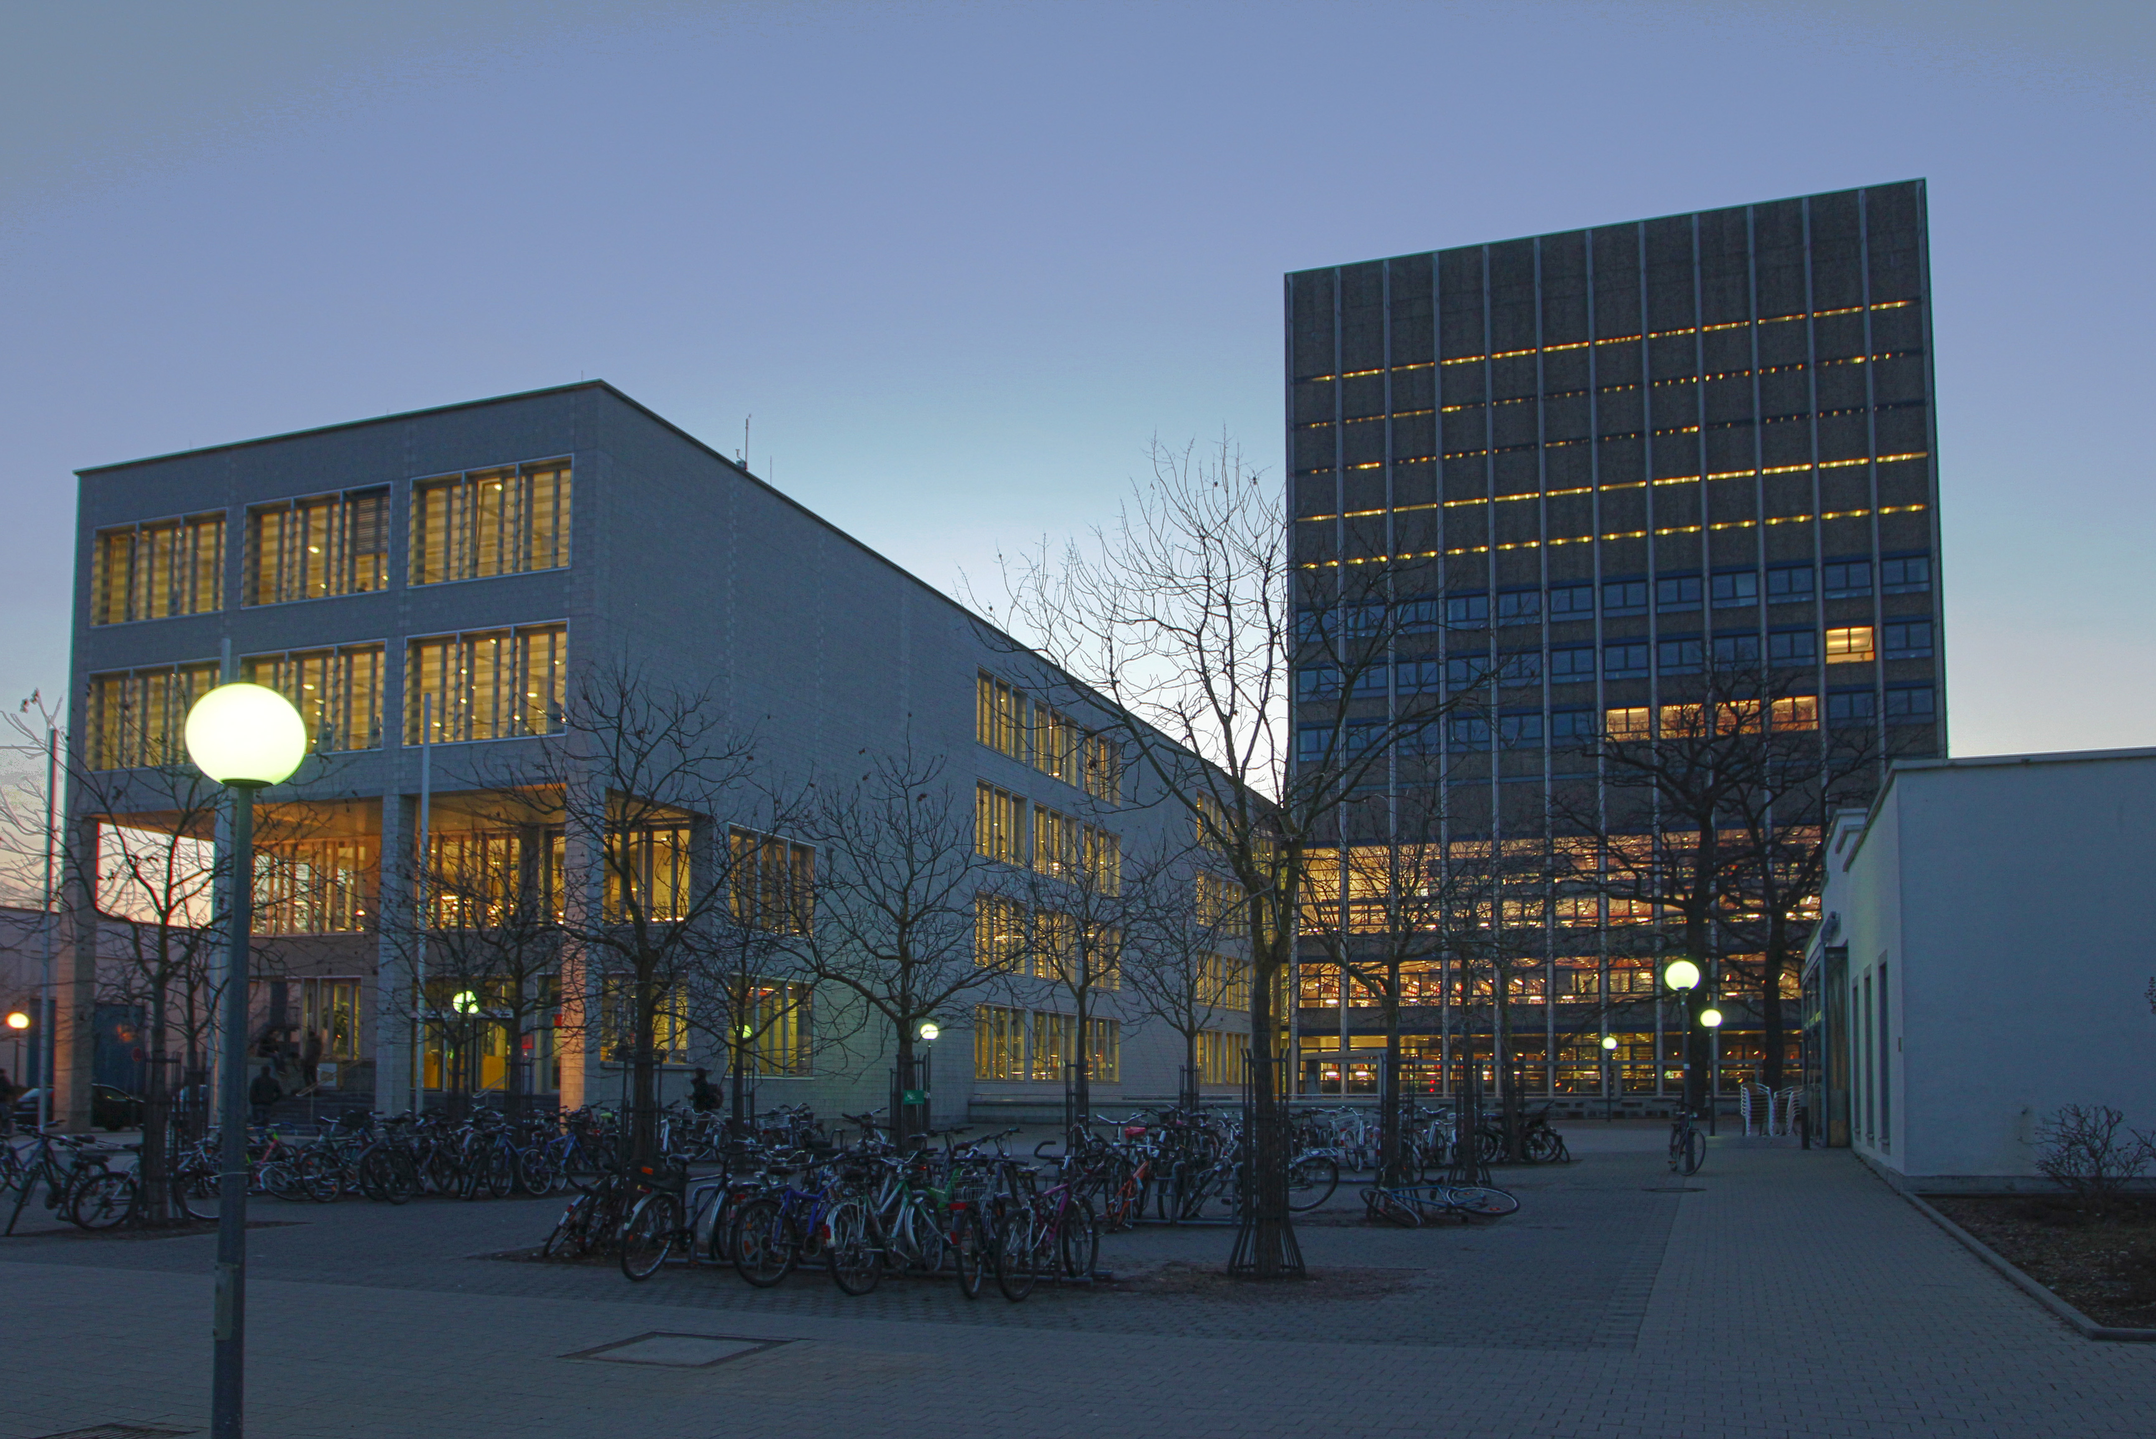 formatting style: figure
Figure 1 formatting style: caption figure
Formatting style: bullet points:
- Opinion yes
- Opinion no
- Opinion what?
Formatting style: equation:
$a^{2}+b^{2}=c^{2}$ (2.1)
Cross-references Table 1 and Figure 1.

References
- Johansen KW (1949) Theory of timber connections. Publication 9. International Association of Bridge and Structural Engineering (IABSE), Basel, Switzerland.
- EN 1995 1-1 (2010) Eurocode 5. Design of timber structures ‒ Part 1-1: General ‒ Common rules and rules for buildings. Comité Européen de Normalisation (CEN), Brussels, Belgium.

